**Assignment - 14 A Job Ready Bootcamp in C++, DSA and IOT**

**Array in C Language**

**1. Write a program to calculate the sum of numbers stored in an array of size 10. Take**

**array values from the user.**

#include<stdio.h>

int main()

{

int a[10],i,sum=0;

printf("Enter a data in array\n");

for(i=0;i<10;i++)

scanf("%d",&a[i]);

for(i=0;i<10;i++)

sum+=a[i];

printf("sum is %d",sum);

return 0;

}

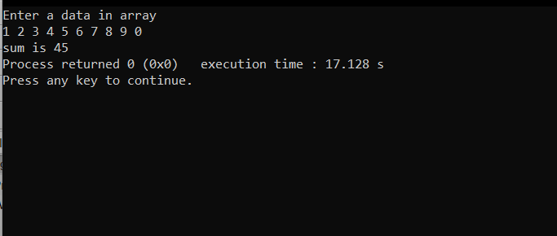

**2. Write a program to calculate the average of numbers stored in an array of size 10.**

**Take array values from the user.**

#include<stdio.h>

int main()

{

int a[10],i;

float avg=0;

printf("Enter a data in array\n");

for(i=0;i<10;i++)

scanf("%d",&a[i]);

for(i=0;i<10;i++)

avg+=a[i];

printf("Average is %f",avg/2);

return 0;

}

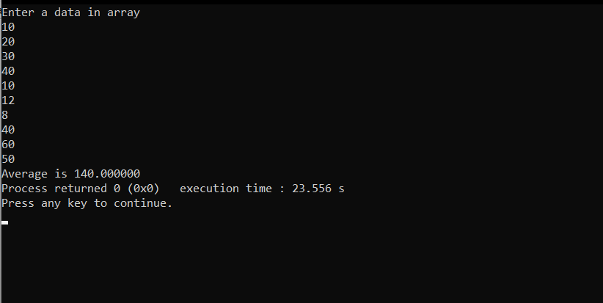

**3. Write a program to calculate the sum of all even numbers and sum of all odd**

**numbers, which are stored in an array of size 10. Take array values from the user.**

#include<stdio.h>

int main()

{

int a[10],i,even=0,odd=0;

printf("Enter a data in array\n");

for(i=0;i<10;i++)

scanf("%d",&a[i]);

for(i=0;i<10;i++)

{

if(a[i]%2==0)

even+=a[i];

else

odd+=a[i];

}

printf("\nSum of even is %d\n",even);

printf("Sum of odd is %d",odd);

return 0;

}

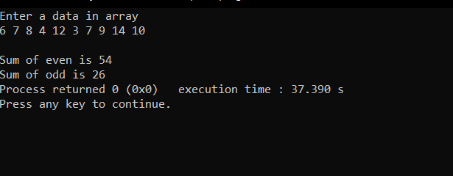

**4. Write a program to find the greatest number stored in an array of size 10. Take array**

**values from the user.**

#include<stdio.h>

int main()

{

int a[10],i,max=-1;

printf("Enter data in array\n");

for(i=0;i<10;i++)

scanf("%d",&a[i]);

for(i=0;i<10;i++)

{

if(max<a[i])

max=a[i];

}

printf("Greater number is %d",max);

return 0;

}

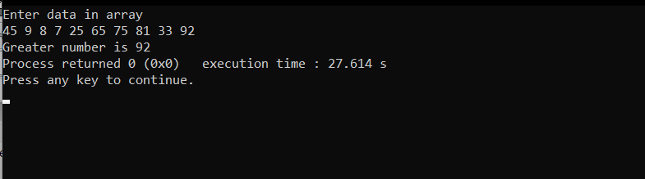

**5. Write a program to find the smallest number stored in an array of size 10. Take array**

**values from the user.**

#include<stdio.h>

int main()

{

int a[10],i,min=99999;

printf("Enter data in array\n");

for(i=0;i<10;i++)

scanf("%d",&a[i]);

for(i=0;i<10;i++)

{

if(min>a[i])

min=a[i];

}

printf("Smaller number is %d",min);

return 0;

}

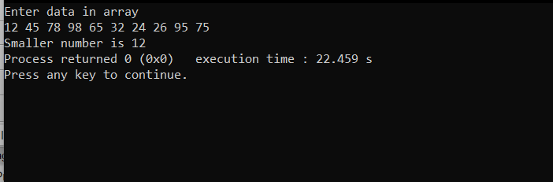

**6. Write a program to sort elements of an array of size 10. Take array values from the**

**user.**

#include<stdio.h>

int main()

{

int a[10],i,j,s=0;

printf("Enter data in array\n");

for(i=0;i<10;i++)

scanf("%d",&a[i]);

for(i=0;i<9;i++)

{

for(j=i+1;j<10;j++)

{

if(a[i]>a[j])

{

s=a[i];

a[i]=a[j];

a[j]=s;

}

}

}

for(i=0;i<10;i++)

{

printf("%d ",a[i]);

}

return 0;

}

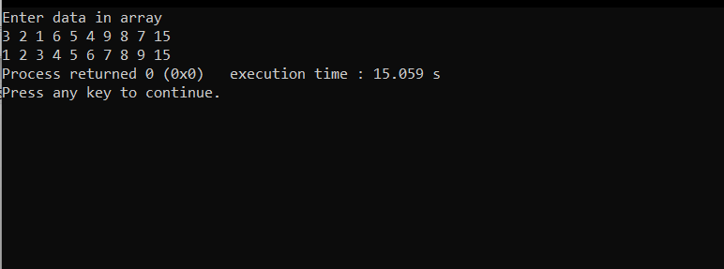

**7. Write a program to find second largest in an array. Take array values from the user.**

#include<stdio.h>

int main()

{

int a[10],i,j,s=0;

printf("Enter data in array\n");

for(i=0;i<10;i++)

scanf("%d",&a[i]);

for(i=0;i<9;i++)

{

for(j=i+1;j<10;j++)

{

if(a[i]>a[j])

{

s=a[i];

a[i]=a[j];

a[j]=s;

}

}

}

printf("%d",a[8]);

return 0;

}

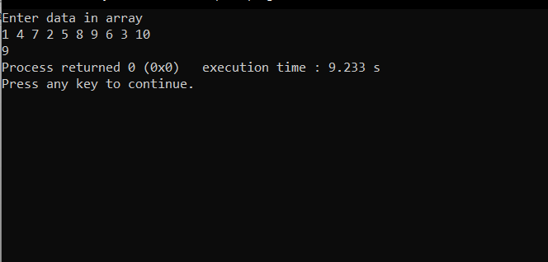

**8. Write a program to find the second smallest number in an array. Take array values**

**from the user.**

#include<stdio.h>

int main()

{

int a[10],i,j,s=0;

printf("Enter data in array\n");

for(i=0;i<10;i++)

scanf("%d",&a[i]);

for(i=0;i<9;i++)

{

for(j=i+1;j<10;j++)

{

if(a[i]>a[j])

{

s=a[i];

a[i]=a[j];

a[j]=s;

}

}

}

printf("%d",a[2]);

return 0;

}

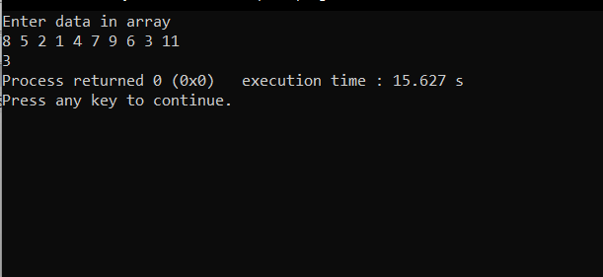

**9. Write a program in C to read n number of values in an array and display it in reverse**

**order. Take array values from the user.**

#include<stdio.h>

int main()

{

int a[10],i;

printf("Enter data in array\n");

for(i=0;i<10;i++)

scanf("%d",&a[i]);

for(i=9;i>=0;i--)

{

printf("%d ",a[i]);

}

return 0;

}

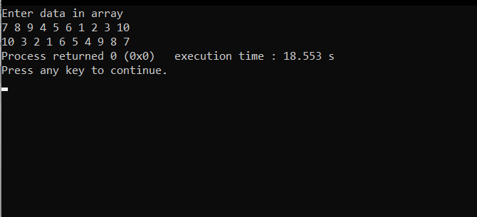

**10. Write a program in C to copy the elements of one array into another array. Take array values from the user.**

#include<stdio.h>

int main()

{

int a[10],i,b[10];

printf("Enter data in array\n");

for(i=0;i<10;i++)

scanf("%d",&a[i]);

for(i=0;i<10;i++)

{

b[i]=a[i];

printf("%d ",b[i]);

}

return 0;

}

